Event Management and Safety Plan
Event Title:
Event Date:

Plan Production and Control
This plan has been produced by ______________________, who on behalf of _______________________, assumes the responsibility of Event Manager and Safety Officer on the day for this event.

Contents
- Event Outline
- Aims and Objectives
- Event Management Structure
- Risk Assessment
- Crowd Management
- Emergency Procedures
- Evacuation Procedures
- Road Traffic Management
- Severe Weather and Event Cancellation
- First Aid
- Fire Precautions and Equipment
- Safeguarding
- Communications
- Media
- Waste Management
- Toilets
- Catering
- Lighting
- Noise Management
- Lost Children
- Health and Safety
- Equality Impact Statement

Also provided:
- Risk Assessment
- Public Liability Insurance

  - Event Outline

  - Plan Aims and Objectives

This plan aims to provide a complete event document in order that all of the individual agencies and organisations who will be participating in the event clearly understand both their own roles and how these roles interact with other contributors.
The Plans main objectives are:
- to provide a successful, safe, enjoyable event
- to consider and plan for possible problems
- to identify trigger points for implementation of emergency procedures

  - Event Management Structure

Event Manager: ______________________________________________________________________
Event Team Members: _________________________________________________________________

  - Risk Assessment

Detailed Risk Assessments relating to this event are provided separately as an appendix.

Summary Risk Assessments

Item | Severity | Likelihood
Attendees/General Public | H/M/L | H/M/L

  - Crowd Management

  - Emergency Procedures

  - Evacuation Procedures

If the Event Manager decides that an evacuation of the main event area is required, then they will do the following:

- Decision is clearly recorded - timed and the reason for implementation noted
- Stewards and police take positions
- Make an announcement following police consultation
- Note the reason for the evacuation and the time

  - Road Traffic Management

  - Firework and Pyrotechnic Management

Fireworks and pyrotechnics are not to be used within Centre Vale Park.

  - Severe Weather and Event Cancellation

  - Flooding Risk

Centre Vale Park contains a flood alleviation area (Appendix C) which has Environment Agency managed remote controlled gates. The flood basin is next to the Bandstand audience area. The audience area is raised above the flood basin however this will be monitored as with the severe weather conditions. Event organisers will be informed of the flood alleviation area and any Environment Agency flood warnings will be taken into consideration before an event takes place.

No vehicles will be permitted on the grass/flood alleviation area.

  - First Aid

  - Fire Precautions and Equipment

  - Safeguarding

Our Safeguarding lead is: ____________________________

We confirm that we have a safeguarding policy.

  - Communications

All key Event Team members will be accessible via mobile phones, with a list of phone numbers shared ahead of the event.

  - Media

  - Waste Management

  - Toilets

  - Catering

  - Lighting

  - Noise Management

  - Park Weight Limits

Several paths in Centre Vale Park have weight limits and all event organisers will be informed of these and the BSG and TTC will ensure they are adhered to. (App D)

TTC can not permit use of the grassed area and event organisers will liaise with CMBC in regards to this area however, basic information about the restrictions are included in this event plan.

Purpose of Restrictions
- 4t per axle weight limit for vehicles on grass areas to protect the park’s drainage system, as advised by the Environment Agency.
- During wet conditions, vehicle access must be controlled to prevent damage to the drainage system.
Weight Limit & Penalties
- A 5.6t Gross Vehicle Weight (GVW) limit applies to vehicles accessing restricted areas.
- A £250 penalty per vehicle will be issued if this limit is exceeded.
- This applies regardless of load carried.
Event Organiser Responsibilities
- Pre-Event Vehicle Information:
  - Gather details (GVW, registration, make/model, colour) of all vehicles over 3.5t GVW attending the event.
  - Ensure drivers can provide evidence of GVW on-site.
- Weight Control Plan:
  - Create a documented plan to manage vehicles over and under the 5.6t limit.
  - Plan must include ground protection measures for vehicles exceeding the GVW limit.
- Wet Weather Contingency:
  - Have a plan in place for worsening weather conditions which may increase weight restrictions to include all vehicles.
Vehicle Verification
- Vehicle GVW can be checked via the DVLA website: DVLA Vehicle Information.

  - Lost Children

  - Health and Safety Policy

We set standards and monitor the activities to minimise the risk present to employees, other people on site and to the public. We confirm that we have a Health and Safety Policy, and have provided this to Todmorden Town Council.

  - Equality Impact Statement

Appendix A: Event Timetable

Plan
Date:

Appendix B- Events Map

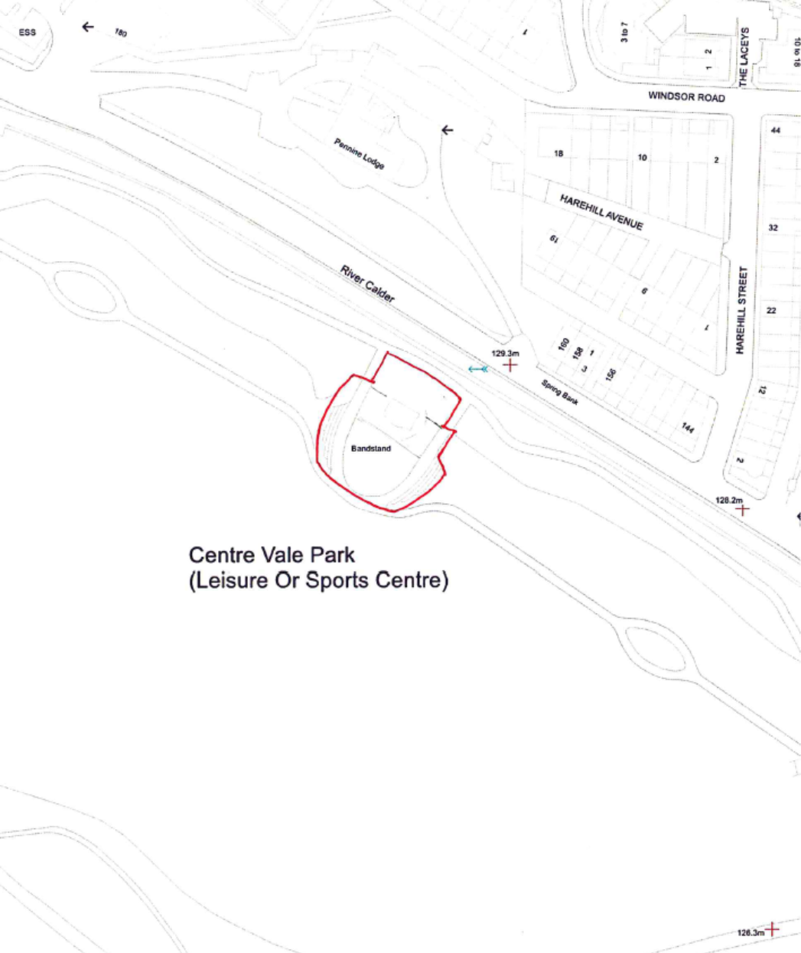
Appendix C – Weight Limits for Centre Vale Park

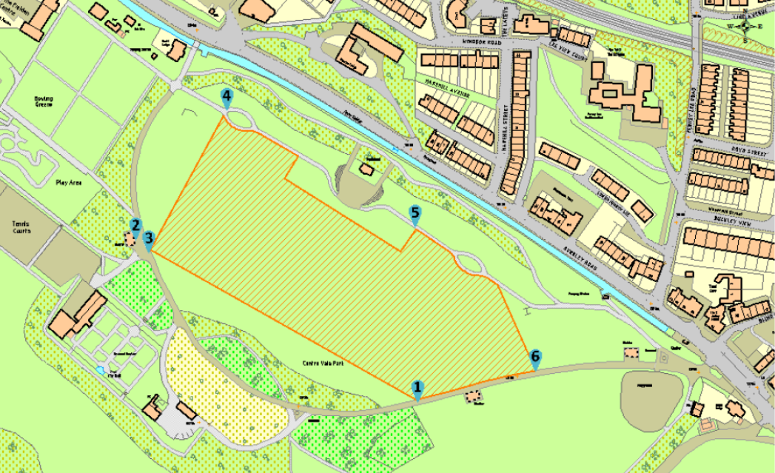

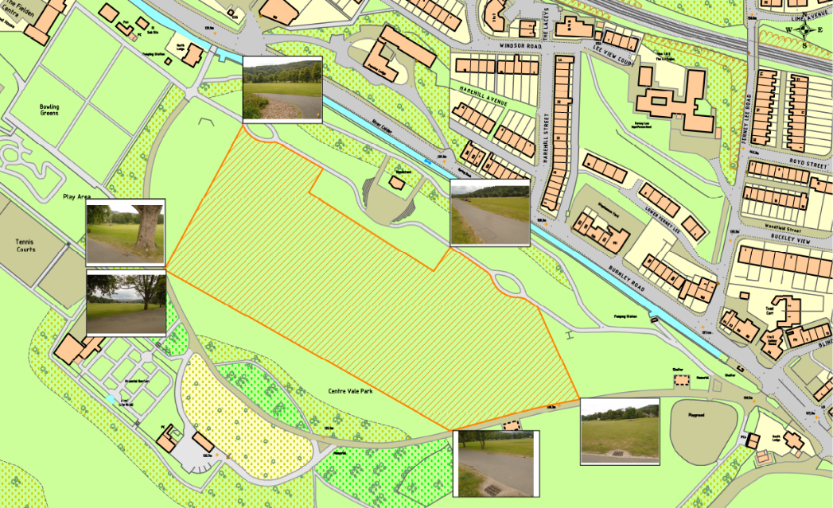

Appendix D - Public Address scripts

Appendix E - Roles and Responsibilities
Roles and responsibilities for the organisations taking part will be provided on an event by event basis:

Activity | Organisation |  | Key Contact

Appendix F: Key Contacts

Organisation | Key Contact | Phone Number

Appendix G – Purple Guide Matrix
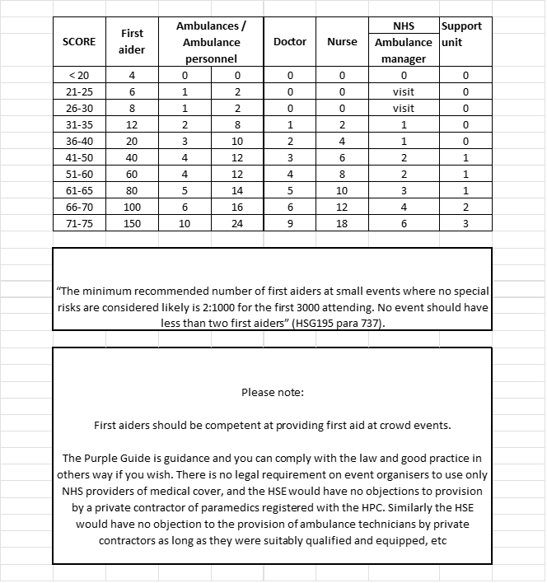

Appendix H: Event safety check List

Safety Inspection Checklist
(before, during and after the event)

Walk through safety inspections should be carried out immediately before and after the event. More than one inspection may be needed during the event. Using this form note all defects and also the remedial action taken. This is not an exhaustive list and care should be taken to identify any other hazards associated with the activities at the event.

Before the event
Location: ____________________________________________________________

Site access/egress
- Are entrances/exits clear? Yes No
- Can emergency vehicles gain access? Yes No
- Are pedestrians segregated from vehicles? Yes No
- Are security precautions in place? Yes No
- Have adequate signs been provided? Yes No

Site condition
- Is site free from tripping hazards e.g. cables, potholes, footpath defects etc.? Yes No
- Are permanent fixtures in good condition e.g. seats, fencing, signage etc.? Yes No
- Has vegetation been cut back, debris removed and the area made safe? Yes No
- Have current weather conditions created new hazards to be addressed? Yes No

Activities
- Are all activities sited correctly and checked? Yes No
- Are all potentially hazardous activities segregated and/or fenced as required? Yes No
- Have temporary flags/decorations/bunting been installed correctly and checked Yes No
- Have any unanticipated hazards been introduced? Yes No

Event provisions
- Are first aid facilities in place? Yes No
- Are adequate waste bins in place? Yes No
- Are stewards in place? Yes No

Defects noted: ___________________________________________________________________
_______________________________________________________________________________
_______________________________________________________________________________

Remedial action taken ____________________________________________________________
_______________________________________________________________________________
_______________________________________________________________________________

Printed Name of Inspector:_____________________________________
Signature:___________________________________________________
Date & Time of Inspection:_____________________________________
After the event
Location: ____________________________________________________________

Site access/egress
- Are entrances/exits clear? Yes No
- Can emergency vehicles gain access? Yes No
- Are pedestrians segregated from vehicles? Yes No
- Are security precautions in place? Yes No
- Have adequate signs been provided? Yes No

Site condition
- Is site free from tripping hazards e.g. cables, potholes, footpath defects etc.? Yes No
- Are permanent fixtures in good condition e.g. seats, fencing, signage etc.? Yes No
- Has vegetation been cut back, debris removed and the area made safe? Yes No
- Have current weather conditions created new hazards to be addressed? Yes No

Activities
- Are all activities sited correctly and checked? Yes No
- Are all potentially hazardous activities segregated and/or fenced as required? Yes No
- Have temporary flags/decorations/bunting been installed correctly and checked Yes No
- Have any unanticipated hazards been introduced? Yes No

Event provisions
- Are first aid facilities in place? Yes No
- Are adequate waste bins in place? Yes No
- Are stewards in place? Yes No

Defects noted: ___________________________________________________________________
_______________________________________________________________________________
_______________________________________________________________________________

Remedial action taken ____________________________________________________________
_______________________________________________________________________________
_______________________________________________________________________________

Printed Name of Inspector:_____________________________________
Signature:___________________________________________________
Date & Time of Inspection:_____________________________________

Appendix I: Emergency / Evacuation Procedure incident log

Incident Log

Incident Location of Incident Date
Time

The following section to maintained as incident Progresses

Date | Time | Event/Action Taken | Reason(s)

Name Signed Job Title

Appendix J: Accident Log

Accident Report Form

Event name Event venue Event date

Date and time of accident:

Date and time reported:

Person reported to
Details in accident book? Circle Yes No

Details of injury (specify left or right side), and/or loss or damage

First-aid administered (please give name)

Please circle relevant answer

Ambulance called Yes No

Taken to hospital Yes No

Name and address of hospital attended

Taken home Yes No

Circumstances of accident and location

Person completing this form:
Name:
Address:

Post Code:
Telephone number:

Signature:

Appendix K: Risk Assessment
Date: Group: Risk assessment carried out by:

Hazard  Describe the thing that may cause harm. | Effect  What kind of harm could be caused? | Risk Rating  High, medium or low (likelihood x severity of consequences) | Control  What should happen to reduce the risk? | Responsibility  Who will ensure the control is carried out? | Residual Risk Rating  The level of risk after control has been applied

